Communication Title - Standards for writing
Paper Title
Juan-Antonio Lorca-Andríaª, Nombre Autor^{b} y Nombre Autor^{c}
ªChemical Engineering Institute, Universitat Politècnica de València, , email@dominio.es; ^{b}More information on the authors (affiliation, ORCID hyperlink associated with the image, email) and ^{c}More information on the authors (affiliation, ORCID, email).
How to cite: Surname, Name; Surname, Name and Surname, Name (2027). Title of the contribution. In proceedings book: Proceedings book title. May 27 – 29, 2027, Valencia (Spain). https://doi.org/10.4995/Iberian27.2027.****

Abstract
English abstract…

Keywords: English keywords separated by semicolons…

Introduction
The papers will have a minimun length of 6 pages and maximun of 8 pages and should consist of the following sections:
- Introduction
- Aims and objectives
- Methology
- Results
- Conclusions
- References

Guidelines for the drafting of full-text papers
This document can serve as a model for the formato f the complete texts of the papers.
All texts, figures and tables Will be included within the margins of the template.

Fonts and formats
The fonts, sizes and spacing to be used are those indicated in this document, which can be us as a template.

Títle
Titles should have a maximun of three levels numbered with the decimal system. The main titles (title 1) should be written in Times New Roman, N (bold), 11. The second level (titles 2) should be written in Times New Roman, N (bold), 10. The third leve lof titles (titles 3) should be written in Times New Roman K (italic) 11. After each heading, do not leave a blank line; only one blank line should be left before starting a new paragraph.

Figures and table captions
Figure and table captions should be written in Times New Roman K (italics) 9 pts. The text included in the figures should be of sufficient size to be legible, i.e. the fornt should not be les than 9 pts.

Graphics (drawings and photographs) and tables
To facilitate file transfer, a .jpg resolution of approximately 150 kB should be used.
All images and photogrpahs should be inserted in the document.
Figures and tables should be placed in a place closet o where they are first cited. A Fig. caption followed by the number should be placed under each image or photograph and a Table caption followed by a correlative number under each table.
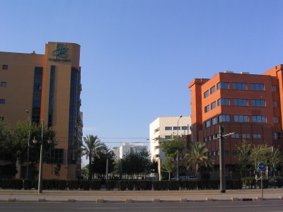
Fig. 1 Caption. Source: Edwards, B (2005)
Figures, photographs and tables Will be aligned centered. Tables Will have border lines at the top and bottom and under the caption.

Table 1. Title of the Table. Source: Edwards (2005)
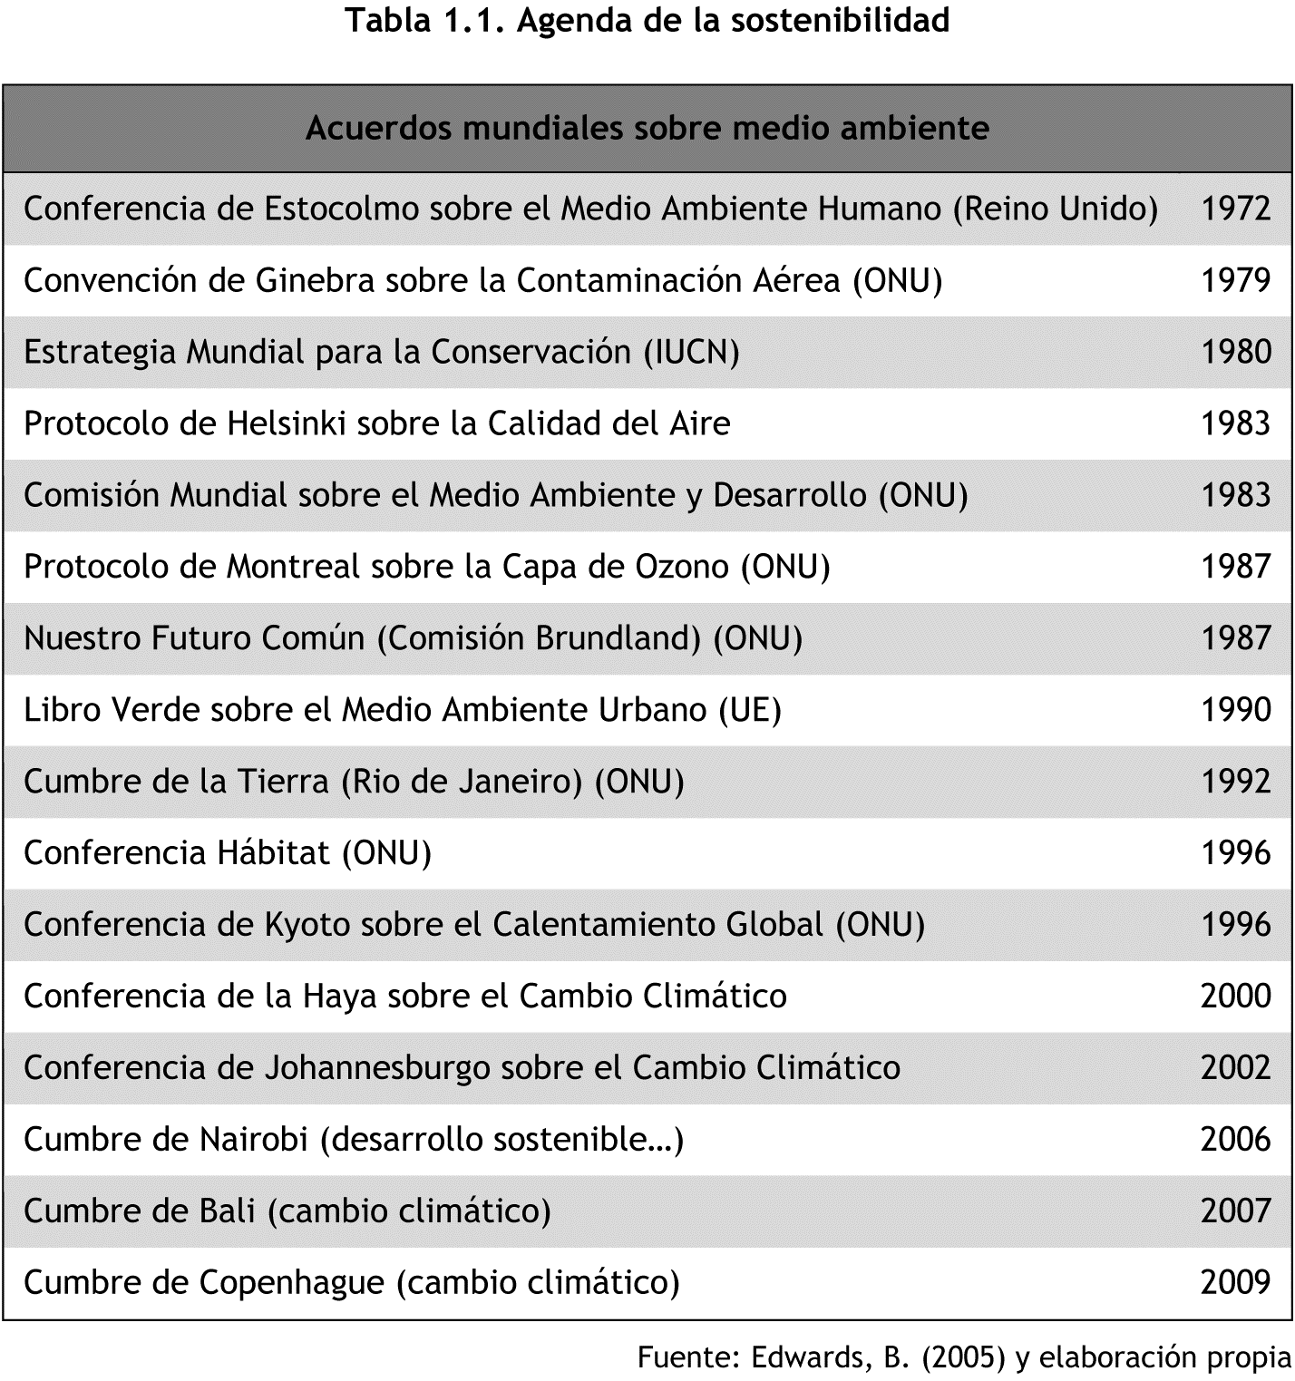

Table 2. Title of the Table
Dimensiones  de la escala | Nombre | Items del cuestinario
1 | Claridad | 1 a 7
2 | Motivación | 8 a 12
3 | Recursos | 13 a 21
4 | Evaluación | 22 a 30

Formulas
Formulas and/or equations Will be inserted using the equation editor integrated in Microsoft Word and Will have a number in parentheses to the right of them to indicate their order, for example:
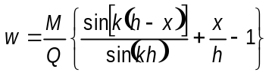 (1)

How to cite within the text?
To reference AUTHORS: The Surname and the year in parentheses.
i.e. (Aucejo, 2014)
To reference SIMULATIONS AND GAMES (SOFTWARE): with CAPITAL LETTERS the title of the game/simulation, without year or autor.
i.e. In the game BAFA BAFA, two cultures come into contact...
i.e. In the well-known INTERNATIONAL MARBLES HEX GAME, players...

References
All references are presented in alphabetical order by surname without differentiating between paper and electronic, without bullets, with French indentation and, especially if extensive, with smaller font size. Information on punctuation and typography is implicit in the description and in the following examples :
Book
SURNAMES IN CAPITAL LETTERS, First name initial (year). Title in italics. Place of publication: editorial. [one author]
TOMÁS GIRONÉS, J. (2013). El gran libro de Android. Barcelona: Marcombo. [two/three authors: include all surnames and names]
ALEGRE, A., ORTIZ MIRANDA, E.D. y MORENO PÉREZ, O.M. (2012). Lecciones de política rural: la política rural de la Unión Europea y su aplicación en España. Valencia: Universitat Politècnica de València. [four or more authors : et al.]
ARAGÓN REVUELTA, P. et al. (2006). Técnicas instrumentales: manual de laboratorio. Valencia: Editorial Universitat Politècnica de València.
Journal
Title in italics (year). Identification of the issue with date and/or number. Place of publication : publisher. Series (optional).
Papers de Turisme (1997), vol. 1. Valencia: Fundación Cavanilles de Altos Estudios Turísticos.
Concreta: sobre creación y teoría de la imagen (2012). Valencia: Editorial Concreta.
Chapter of a book
[chapter title in quotation marks]
SURNAME, First name initial (year). “Chapter title in quotation marks” in lowercase Surname, Initial of name. Title of the book in italics. Place of publication : publisher. Optional information : volume, pages,…
SANCHEZ MARTINEZ, F. J., ANDRES MORENO, C. (2011). “Análisis geomorfológico” en Lastra Fernández, J., Sánchez Martínez, F. J. Guía metodológica para el desarrollo del Sistema Nacional de Cartografía de Zonas inundables. Madrid: Ministerio de Medio Ambiente y Medio Rural y Marino.
Article from a magazine or newspaper
[title of the article in quotation marks]
SURNAME, First name initial (year). “Title of the article in quotation marks” in Title of the journal in italics. Edition, location of the article in the journal (year, volume, number, pages).
SHENGRU TU y ABDELGUERFI, M. (2006). “Web Services for Geographic Information Systems” en IEEE Internet Computing, vol. 10, issue 5, p. 13-15.
GODEO, O. R. (2011). “Marine Ecosystem Acoustics, a conceptual approach to enhanced process understanding and system evaluation” en The Journal of the Acoustical Society of America, 129, 4, 2696.
Electronic references (book, journal or article)
The same information is given as if the document were published on paper, but the <URL> and [Query date] must also be given.
CELLARY, W. y WALCZAK, K. (2012). Interactive 3D Multimedia Content: Models for Creation, Management, Search and Presentation. London: Springer. <http://link.springer.com/book/10.1007/978-1-4471-2497-9/page/1> [Consulta: 15 de junio de 2013].
EOM, Hyo-Eun; LEE, Seok-Won (2013). “Human-centered software development methodology in mobile computing environment: agent-supported agile approach”. EURASIP Journal on Wireless Communications and Networking, Vol. 2013 (1), pp.1-16. <http://dx.doi.org/10.1186/1687-1499-2013-111> [Consulta: 15 de junio de 2013]
NOTE: Quality electronic references are reference sources of the same category as those published on paper, sot hey should be referenced together in alphabetical order of the author in the bibliography, regardless of the publication medium.
Conference papers
SURNAME, First name initial (year). “Title of the article in quotation marks” Author of the congress. In Title of the congress (in italics). Place of publication : Publisher. Pages.
MARTOS MOLINA, M. y PULIDO FERNÁNDEZ, J I. (2011) “Retos para la gestión turística de los destinos urbanos culturales en España”. López, D. (coord.) En: Renovación de destinos turísticos consolidados. Congreso de Turismo Universidad y Empresa (13. 2010. Castellón de La Plana). Valencia: Tirant lo Blanch. 223-256
MAMBRILLA, N. y MARTÍN GÓMEZ, C. (2011). “El Dónde y el Cuándo de la Investigación en Protección Contra Incendios” en 4IAU 4ª Jornadas Internacionales sobre Investigación en Arquitectura y Urbanismo. Valencia. Disponible en <http://riunet.upv.es/handle/10251/15017> [Consulta: 3 de marzo de 2012
Thesis, final paper, dissertation… in Riunet
Same as above, but you have to indicate the <URL> y [Consultation date].
TEIRA ARNOSO, A. (2013). Adecuación y validación de una cámara reverberante a escala para ensayos de pantallas acústicas. Trabajo Final de Máster. Valencia: Universitat Politècnica de València, <http://riunet.upv.es/handle/10251/29015> [Consulta: 15 de junio 2013]
Web Page
AUTHOR or ENTITY. Title in italics <URL> [Consultation date] [personal o institutional]
THE UNIVERSITY OF CHICAGO. The Chicago Manual of Style Online. <http://www.chicagomanualofstyle.org/tools_citationguide.html> [Consulta: 14 de junio de 2013]
ESCUELA POLITÉCNICA SUPERIOR DE GANDÍA (2013). Grado en Ciencias ambientales. <http://www.upv.es/titulaciones/GCIA/indexc.html> [Consulta: 10 de junio de 2013] [sin autoría reconocida]
Portal oficial del turismo de España. <http://www.spain.info> [Consulta: 14 de junio de 2013]
Simulations and games (software)
The title is cited first, then the authors:
NAME OF GAME, The. Smith, J. R. & Jones, R. J. (1989). Newbury Park, CA: Sage (2455 Teller Road, Thousand Oaks, CA 91320, USA).
TITLE OF GAME, The. Smith, J. R. & Jones, R. J. (1989). In Brown, B. & Black, B. (Eds.) Guidelines for authors (pp. 55-62). Newbury Park, CA: Sage.
Blogs
It is cited in the same way as an Internet article.
LÓPEZ NICOLÁS, J. M. (2013) “¿Por qué los alimentos ecológicos tienen peor aspecto? La bioquímica y el sentido común lo explican” en Scientia, 23 de mayo. <http://scientiablog.com/2013/05/23/por-que-los-alimentos-ecologicos-tienen-peor-aspecto-la-bioquimica-y-el-sentido-comun-lo-explican/> [Consulta: 15 de junio 2013]
Films
Title in original version (Translated title –if available–. Directors surmane). Production company. Year of publication.
To Rome with love (A Roma con amor. Dir. Woody Allen). [DVD]. Cameo, 2013.
Internet video (Youtube, Vimeo...)
“Redes_373 ¿Para qué sirven las emociones? 1/8”. Youtube <http://www.youtube.com/watch?v=CQ8WJK9qfGo> [Consulta: 24 de mayo de 2011]
LOVE OF LESBIAN & ZAHARA, “Lucha de gigantes”. Vimeo <http://vimeo.com/16249423> [Consulta: 23 de enero de 2013]
Tweet
AUTHOR OR INSTITUTION (@user). “Content of tweet”. Date, time of message, [Twitter]. <URL> [Query date].
BIBLIOCRAIGANDIA UPV (@BiblioCraiGandia). “Ahora la Bibliografía recomendada de tus asignaturas más visible desde Polibuscador #mejorasBiblioteca”. 12 de junio de 2013, 3:00 a.m. [Twitter]. <https://twitter.com/bibcraigandia/status/344756077390344192> [Consulta: 14 de junio de 2013]
Facebook
It is quoted as a tweet. Copy the complete post if it is short, if it is long, give the first few words to make it easier to find.
UN MUNDO EN RED, “En un mundo en red, un organigrama jerárquico no tiene sentido y hace que el sistema o empresa sea rígido y que le cueste adaptarse a la realidad”. 16 de julio de 2013 [Facebook] <https://www.facebook.com/unmundoenred> [Consulta: 17 de julio de 2013]
Distribution lists, newsletters, discussion lists
Title in italics. <URL> [Query date]
INFOLING. Información global sobre lingüística hispánica. <http://infoling.org/home.php> [Consulta: 7 de julio de 2013]
Legislation and regulations (Laws, decrees...)
Country. Title. Publication, date of publication, number, pages.
España. Ley Orgánica 15/1999, de 13 de diciembre, de Protección de Datos de Carácter Personal. BOE, 14 de diciembre de 1999, núm. 298, p. 43088-43099
Standars: (ISO, UNE…)
RESPONSIBLE ENTITY (year). Title in italics. Numer or code of the standard. Place of publication : Publisher.
AENOR (2009). Turismo activo. Requisitos para la prestación del servicio. UNE 188003:2009. Madrid: AENOR.

In this link you will find updated information regarding bibliographic citation :
< http://riunet.upv.es/handle/10251/31590>

